Assignment 2

1. Write a java program for Matrix Addition.
2. Write a java program for Matrix Multiplication.
3. Write a java program to demonstrate method overloading.
4. Write a java program to create a class Point with two data members x & y. Include all constructors and display().
5. Write a java program using static method.

1.What is conditional statement?

2.Write the syntax of switch..case statement.

3.Write the difference between break and continue statement.

4.What is looping statement?

5. Write the difference between while and do..while statement.

6. What is array? How it is created?

7. What is class?

8. What is constructor?

9. What is the use of copy constructor?

10. What is the use of this keyword?  
11. What is method overloading?

12. What is static variable?

13. What is access modifier?

14. Write the difference between instance and static methods.

15. What is object? How it is created?

ANSWERS

1)

import java.util.*;

public class Program

{

public static void main(String[] args) {

Scanner sc=new Scanner(System.in);

int r=sc.nextInt();

int c=sc.nextInt();

int a[][]=new int[3][3];

int b[][]=new int[3][3];

int e[][]=new int[3][3];

try{

for(int i=0;i<r;i++){

for(int j=0;j<c;j++){

a[i][j]=sc.nextInt();

b[i][j]=sc.nextInt();

}

}

for(int i=0;i<r;i++){

for(int j=0;j<c;j++){

e[i][j]=a[i][j]+b[i][j];

System.out.print(e[i][j]+" ");

}

System.out.println();

}

}

catch(NoSuchElementException ie){

System.out.println("give the elements to specific length");

}

finally{

System.out.println("EOP is executed");

}

}

}

Output:

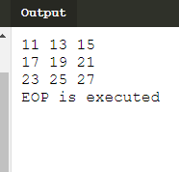

2)

import java.util.*;

public class Program

{

public static void main(String[] args) {

Scanner sc=new Scanner(System.in);

int r=sc.nextInt();

int c=sc.nextInt();

int a[][]=new int[3][3];

int b[][]=new int[3][3];

int e[][]=new int[3][3];

try{

for(int i=0;i<r;i++){

for(int j=0;j<c;j++){

a[i][j]=sc.nextInt();

b[i][j]=sc.nextInt();

}

}

for(int i=0;i<r;i++){

for(int j=0;j<c;j++){

e[i][j]=0;

for(int k=0;k<3;k++){

e[i][j]=a[i][k]*b[k][j];

}

System.out.print(e[i][j]+" ");

}

System.out.println();

}

}

catch(NoSuchElementException ie){

System.out.println("give the elements to specific length");

}

finally{

System.out.println("EOP is executed");

}

}

}

Output:

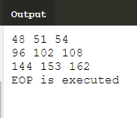

3)

import java.util.*;

public class Loader

{

static int add(int a,int b,int c){

return(a+b+c);

}

static int add(int a,int b){

return(a+b);

}

}

public class Program

{

public static void main(String[] args) {

Scanner sc=new Scanner(System.in);

int n1=sc.nextInt();

int n2=sc.nextInt();

int n3=sc.nextInt();

if(n1>n2){

System.out.println("n1 is greater than n2 : "+Loader.add(n1,n2));

}

else{

System.out.println("n1 is less than n2 so we add n3 also : "+Loader.add(n1,n2,n3));

}

}

}

Output:

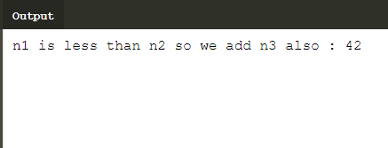

4)

import java.util.*;

public class Basic

{

int a,b;

public Basic(int x,int y){

b = x;

a = y;

}

void display(){

System.out.println("the value of y send from main function : "+a);

System.out.println("the value of x send from main function : "+b);

}

}

public class Program

{

public static void main(String[] args) {

Scanner sc=new Scanner(System.in);

int x=sc.nextInt();

int y=sc.nextInt();

Basic b1=new Basic(x,y);

b1.display();

}

}

Output:

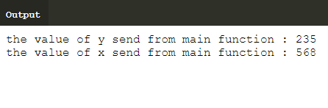

5)

public class Program

{

public static void main(String[] args) {

display();

}

static void display(){

System.out.println("This is simple STATIC METHOD example!!");

}

}

Output:

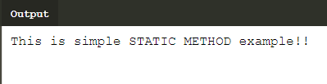

1. **Conditonal statements** is equipped with specific statements that allows us to check a condition and execute certain part of code depending on whether the condition is true or false.
2. **Switch(expression){**

**Case value1:**

**//statements of case1**

**Break;**

**Case value 2:**

**//statement of case2**

**Break;**

**}**

1. The main difference between break and continue is that break is used to immediate termination of loop and continue terminate the current iteration and resume the control to the next iteration of the loop
2. A loop statement is a series of steps or sequence of statements executed repeatedly zero or more times satisfying upto given condition is satisfy.
3. The main difference between a while loop and do while is that while loop ,check condition before iteration of the loop. On other hand the do while verifies the condition after the execution of the statements inside a loop.
4. The array is a container object that holds a fixed number of values in a single type .

It is created as  **int a[]=new int[size].**

1. The class is object oriented programming which revolue in real life entities.A class is a user defined blueprint or prototype from which objects are created.
2. A constructor in java is a special method that is used to initialize objects.The constructor is called when an object of a class is created.It can be used to set initial values for object attributes.
3. A copy constructor in a java class is a constructor that creats an object using another object of the same java class.That helpful when we want to make a deep copy of an existing object.
4. The this **keyword** refers to the current object in a method or constructor. The most common **use** of the this **keyword** is to eliminate the confusion between class attributes and parameters with the same name
5. **Method Overloading** is a feature that allows a class to have more than one **method** having the same name, if their argument lists are different. It is similar to constructor **overloading in Java**, that allows a class to have more than one constructor having different argument lists.
6. A **static variable** is common to all the instances of the class because it is a class level **variable**. It say that only a single copy of **static variable** is created and shared among all the instances of the class.
7. The access modifiers in java specifies the accessibility or scope of a field,method,constructor,or class we can change the access level of fields,constructor ,method and class by applying the access modifiers on it. Access modifiers are of four types ,they are 1)public 2)private 3)default 4)protected.
8. Instance method are methods which require an object of its class to be created before it can be called.Static methods are the methods in java that can be called without creating an object of class.
9. A object is an instance of a class.A class can be defined as template or blueprint that describes the behaviour that object of its type support.